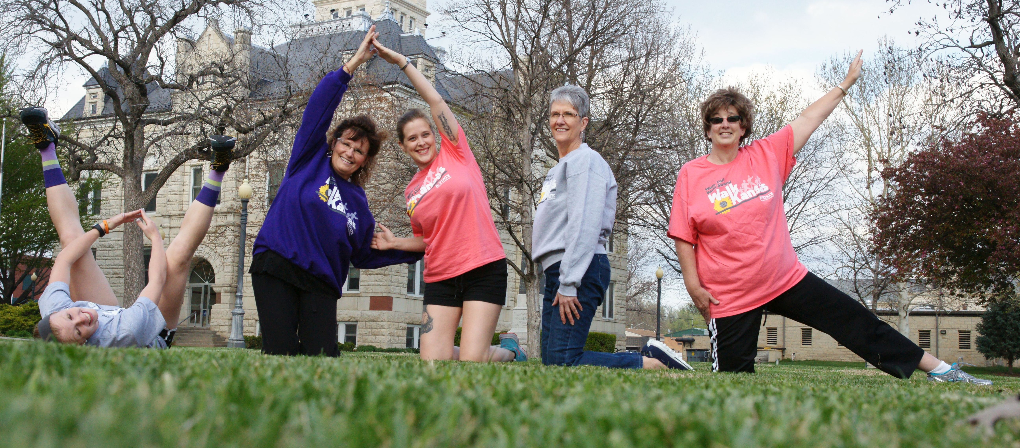

Walk Kansas Photo Challenge
We are seeking inspirational photos from amateur photographers that
illustrate the spirit of Walk Kansas.

What type?
Photos can show kids, families (including pets), and/or adults being physically active; supporting Walk Kansas goals for physical activity and healthy eating; or photos that share a motivational or inspirational message.

How will they be used?
Photos will be used to promote Walk Kansas, displayed on the program website www.walkkansas.org, and used in newsletters and social media.

Who can participate?
Photographer must be a current Walk Kansas participant.

How can I enter?
Submit a high-resolution digital photo before May 12, 2016 to sharolyn@ksu.edu.
(Photos must work in print, so photo size of 3 mb or larger is best.)
Include your name, email, mailing address, and appropriate release forms.
♦ All photos submitted must include a signed Photo Reprint Permission Form:
http://www.communications.k-state.edu/doc/forms/PhotoReprintPermission.pdf
♦ Photos that show faces of individuals must also include a Publicity/Photo Release signed by each individual:
http://www.communications.k-state.edu/doc/forms/PhotoConsntRlsForm.pdf
♦ All photos submitted become the property of K-State Research and Extension.

Are there incentives for submitting a photo?
Each photographer that submits a selected photo will receive a Walk Kansas SportTek shirt of their choice.
Only one incentive item will be awarded per person.
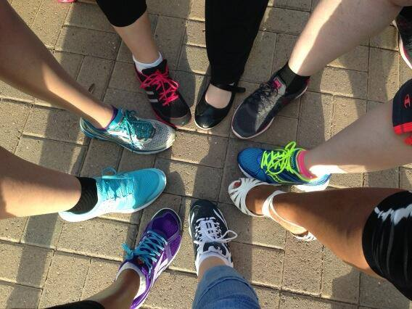

Send signed release
forms to:
NE Area Extension Office
1007 Throckmorton Hall
Manhattan, KS 66506

Questions?
Contact Sharolyn Jackson,
sharolyn@ksu.edu, 785-532-2273.

