Exhibitor Group (Family) Entry
Important Reminders
- Your fair probably has dates when entry is accepted into the fair. Be sure to complete your entries (including the final “Submit” step) prior to the cut-off date.
- Register all entries for each exhibitor in the family before proceeding to the Payment section.
- Be sure to click the “Submit” button when you have completed your entries. Entries are not final until they have been submitted.
- Check your email inbox for a confirmation email with a list of your entries and any related fees.
- You will receive a second email when your entries have been approved by your fair or show.

- You may access your Fair or Show from their direct link or go to http://www.fairentry.com and click “Find Your Fair”. |  | 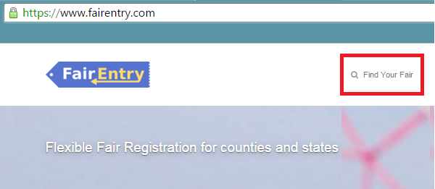
- Filter by your state, click Search, and then click on the correct fair. |  | 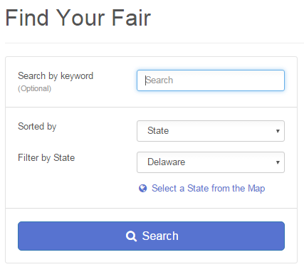
- If you have registered for a Fair with FairEntry before, enter your login information.  - If you have not registered with FairEntry before, select to Create a New Account. Follow the instructions to create your account. |  | 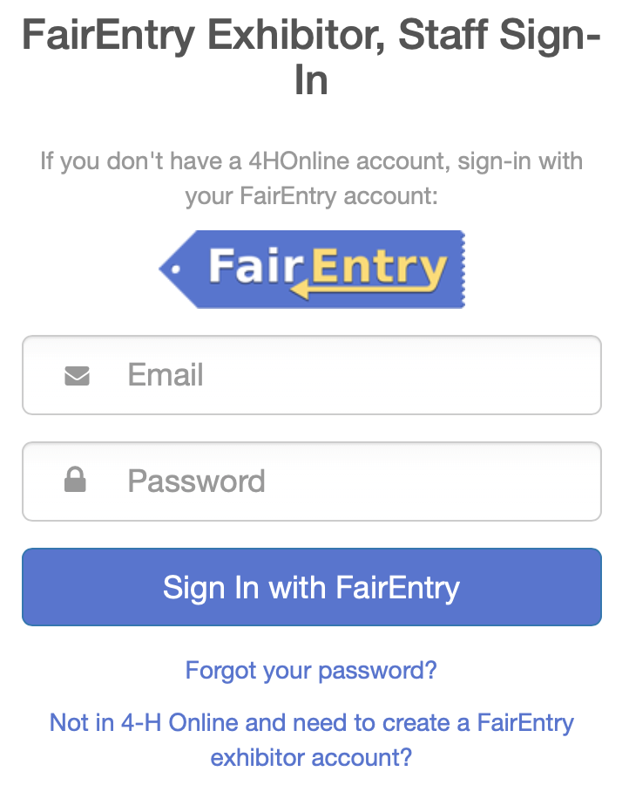
- Click “Begin Registration” |  | 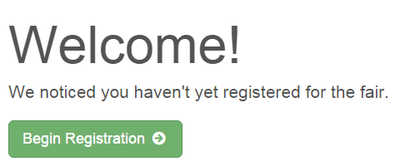
Exhibitor Information  If your fair is configured to accept both individual and team entries, click on the appropriate choice for your entry. Some fairs may only be configured for individual entries. |  | 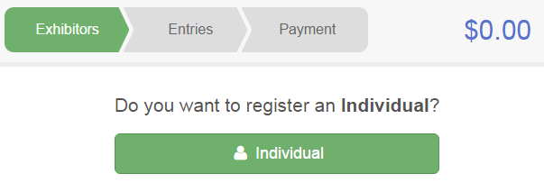
- Enter the exhibitor information into the required fields. Some forms may require different information depending on the Fair or Show. |  | 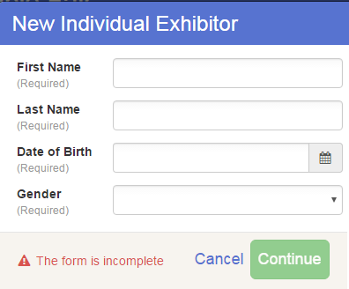
- (If you entered/spelled something incorrectly on the previous screen, you have the option to Delete this Exhibitor on this screen.) Enter the information on the Contact Info screen—the only required field is the top Home Phone Number. You can use the same email address that you used to create the account, or an alternate one unique to the exhibitor. If they wish to receive text messages, enter the cell phone number and carrier. That number can be the same as the Home Phone Number entered above, or different. Click Continue when you are finished entering data. |  | 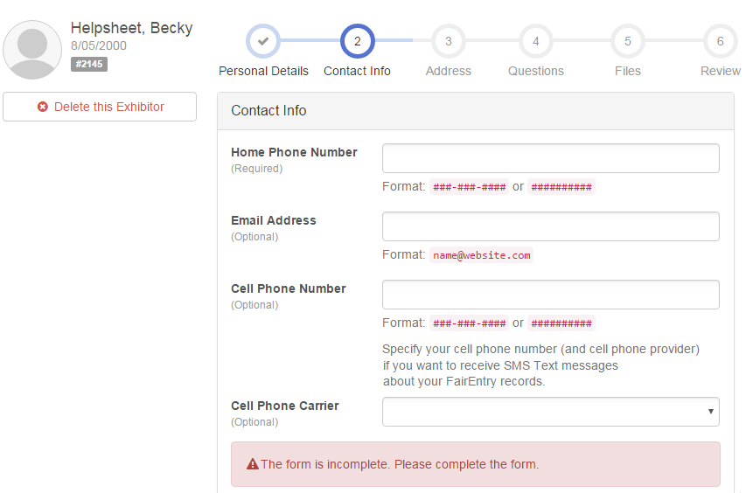
- Enter the mailing address. All fields, except Address continued, are required. If the exhibitor has the same address as another exhibitor in the Exhibitor Group, simply click “Copy” to add the address to the current Exhibitor record. Click Continue when all information is entered correctly.  - If your fair or show requests a Social Security Number for 1099 purposes, that will be Step 4 on the progress bar. Social Security Numbers are fully encrypted and only the last 4 digits will be visible after the number has been saved.  - If your fair or show asks additional questions, those will be step 4 or 5 on the progress bar at the top. Answer any questions, and click Continue.  If your fair requires you to upload any files for the exhibitor, those will be step 5 or 6 on the progress bar. Upload requested files, and click Continue. |  | 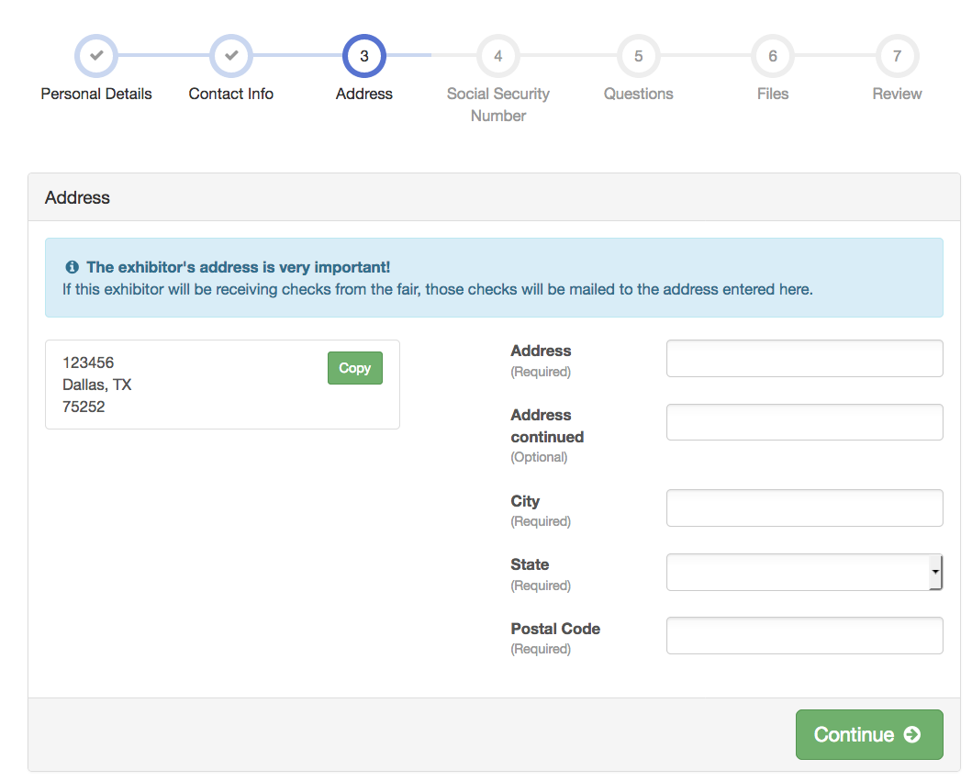
Review the exhibitor information. If any information is incorrect, click the green Edit button in the appropriate group to change it. When all information is correct, click Continue to Entries. |  | 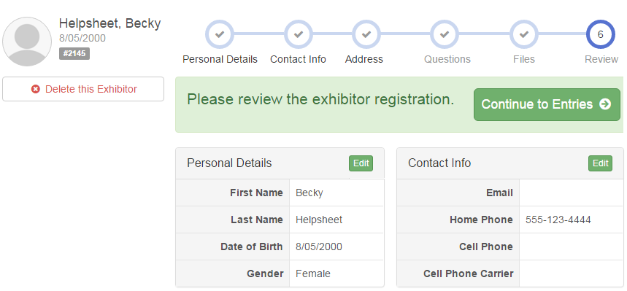
Creating Entries
Each exhibitor can have multiple entries. One entry must be made for each item, animal, class, etc. For example, if an exhibitor is bringing 2 photographs, two entries into the photography class must be created. If an exhibitor is showing one horse in 5 events, five class entries must be created. Once all entries have been created for the first exhibitor, you have the choice of creating another exhibitor in this exhibitor group (and entries) or proceeding to check-out (submitting the entries, whether or not fees are charged).

- Click Add an Entry beside the correct exhibitor (if more than one has been created). |  | 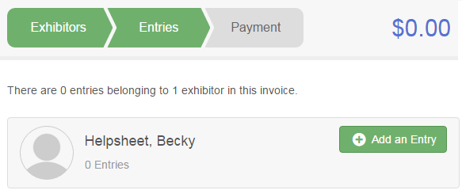
- Click Select beside the first department you wish to enter. Any departments that are not available for entry will be noted as “Not Available” with a short explanation.  - After you select a department, you will see a list of divisions to select from, and then a list of available classes. Also notice that there are blue “Change” links in case you mistakenly select an incorrect department, division, or class.  After you have selected the class, click the green Choose button. |  | 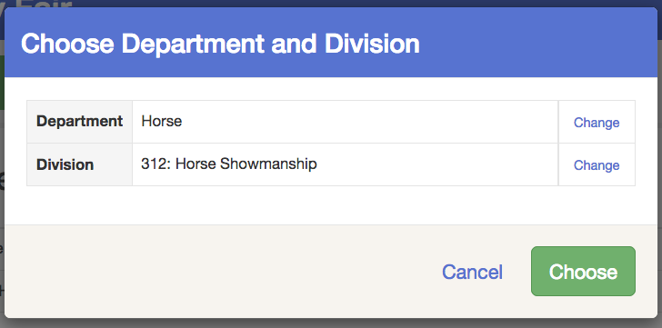
Multiple Entry Process
- If your fair or show has turned on the Multiple Entries option for this area, you will see a screen similar to the view at the right. If you do not see checkboxes next to each class, this area uses the single-entry process (see step 14).  - Click Change to select the Club to which these entries will be associated.  - If this is an Animal Entry, click Add Animal and enter the Animal’s details.  - If this is a pen or group entry, Add multiple animals and then select to Enter a pen of animals.  - Select which animals will be part of this entry (NOTE: these animals will be available for this exhibitor to use in other entries, if needed).  Check the box next to each class this animal will enter. | 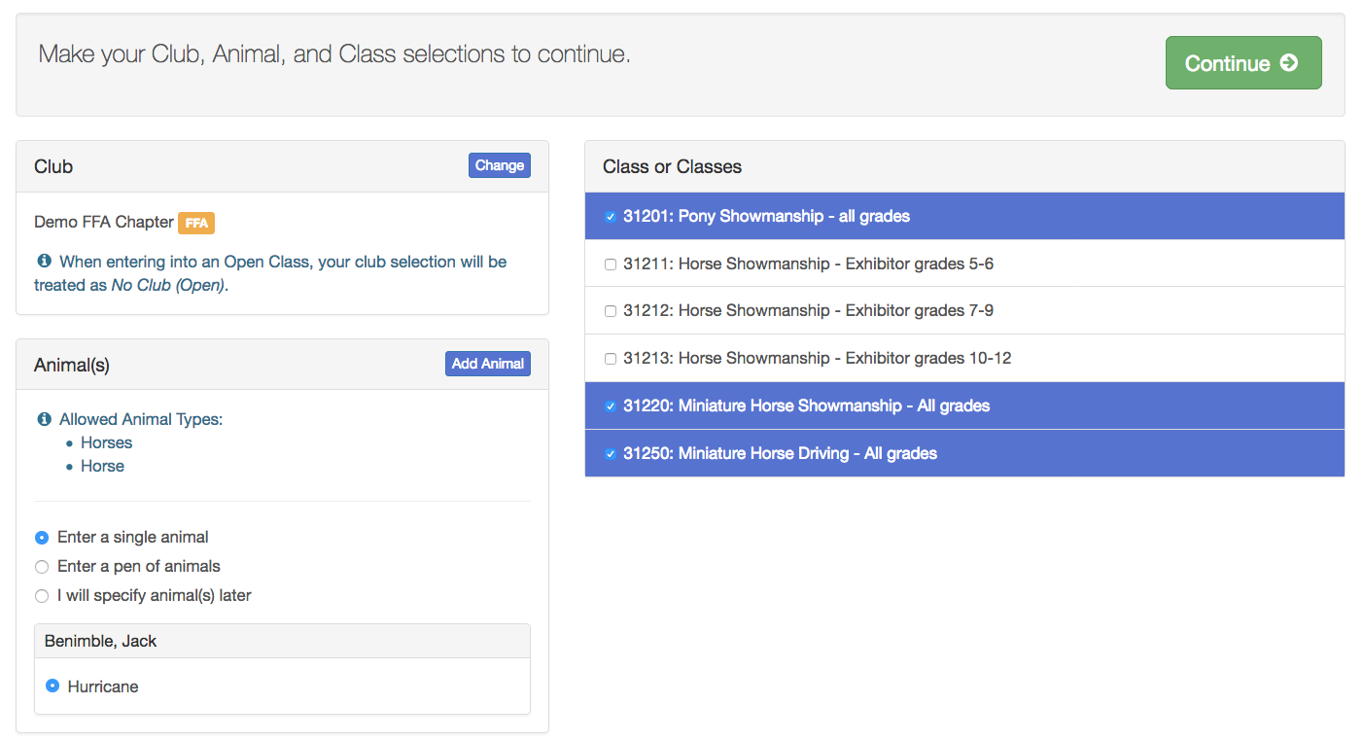
If this is not an animal entry or if animals will be added at check-in, simply select the classes and number of entries in each class that you would like to create for this exhibitor. Click Continue | 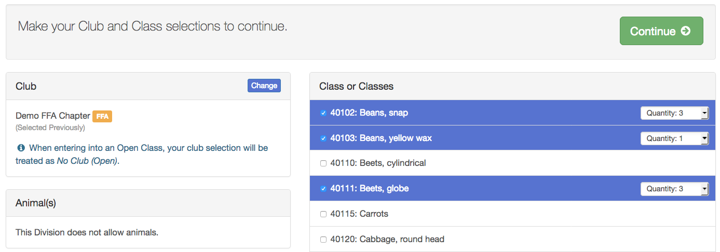
- Review the entries. If you need to make any changes, click Cancel. If everything is correct, click Create Entries. | 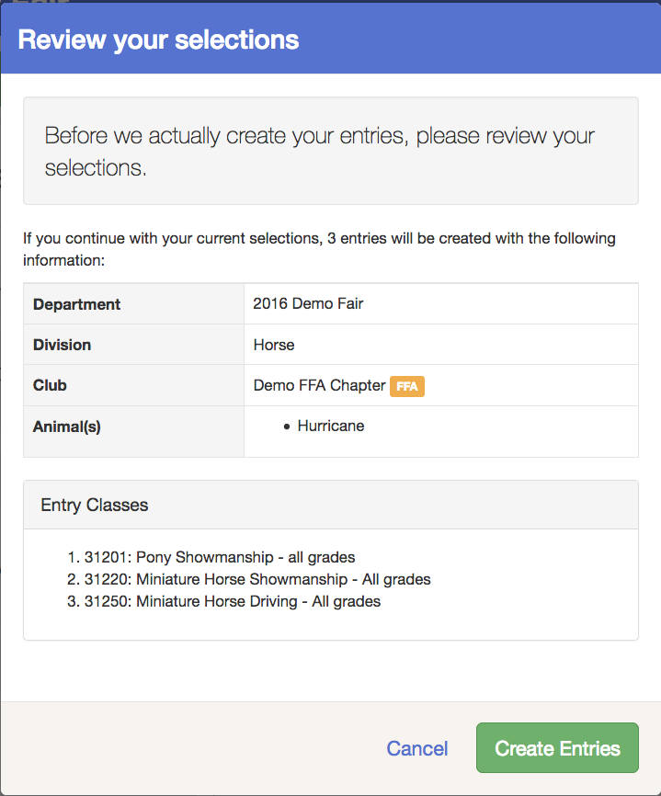
- If you need to add another exhibitor, click on the Exhibitors button at the top left and repeat the steps to create a new exhibitor.  - If all entries are complete, click Continue to Payment.  - If you need to add more entries for an existing exhibitor, click Add an Entry. | 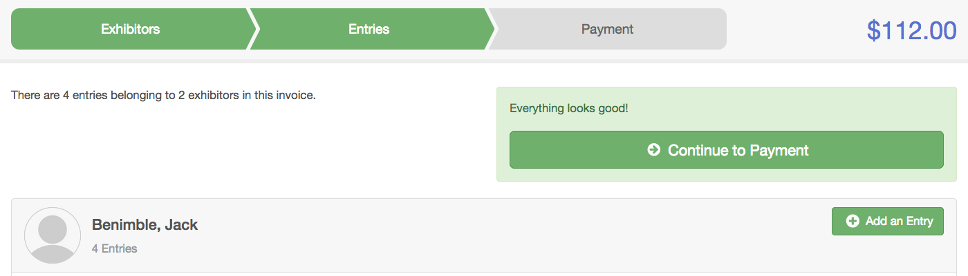  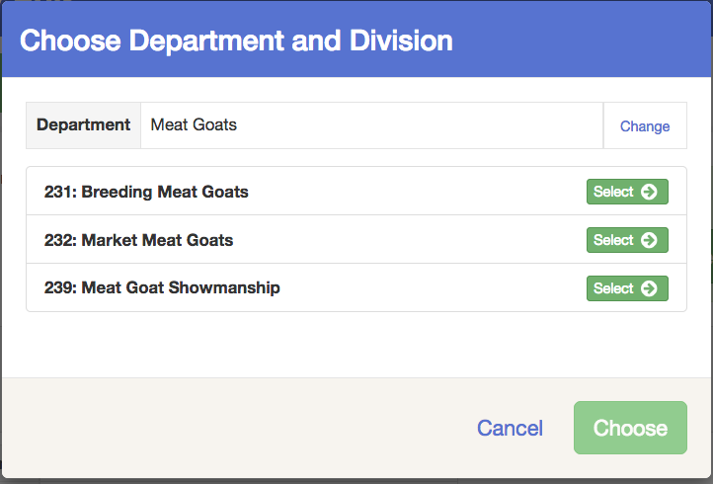
Single Entry Process
- If your screen does not resemble the picture on the right, your fair may have used the multiple entry process in this area. Repeat steps 5-10.  - If your screen does resemble this one, select the Class.  - Click Continue |  |  | 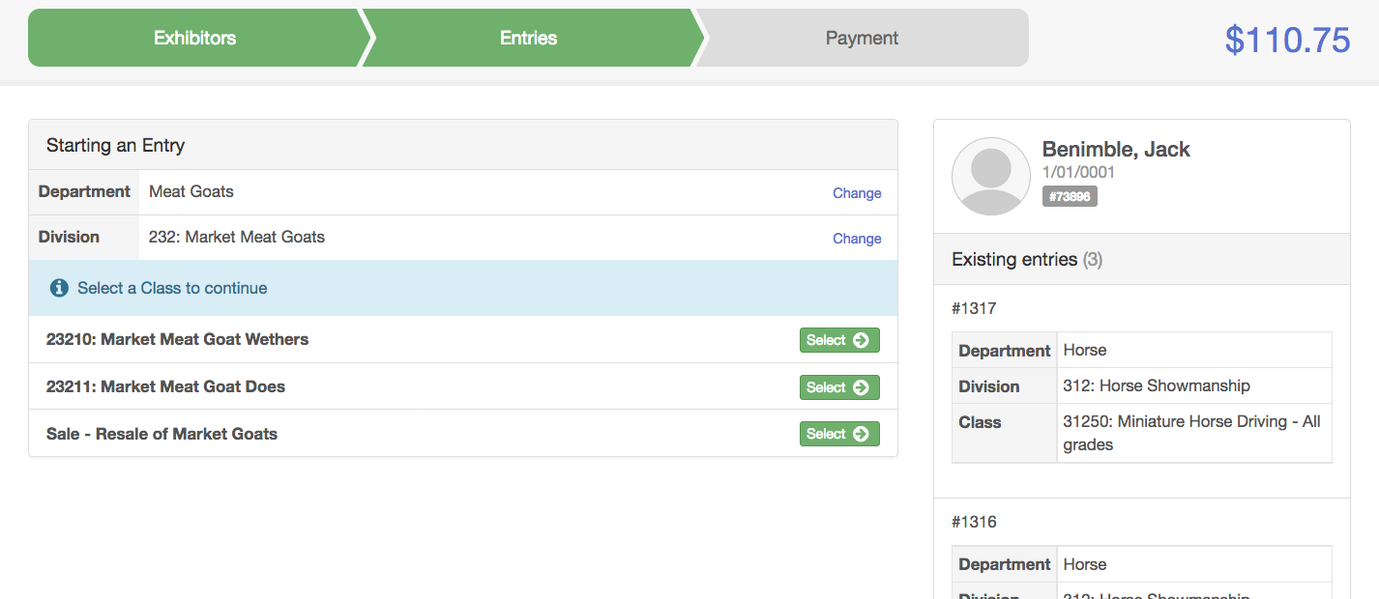
- Select a Club or Chapter for this entry. If this is an open class entry a Club or Chapter may not be required.  - If this is not an animal class entry, follow the instructions on-screen to enter any additional information such as Entry Description, Custom Questions or Custom Files associated with that entry. | 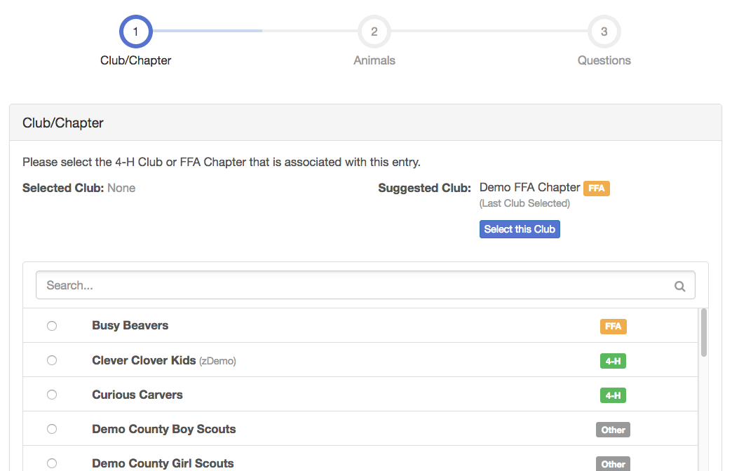
- If this is an animal class entry, you may be required to specify which animal will be exhibited in this class; that may be optional; or you may NOT be able to specify the animal at entry time. If you are able to do that, you will see the option to “Add an animal”.  - You will have two choices. Select “Choose an Existing Animal Record” to import and select animals from 4HOnline or animals already entered in FairEntry. Choose “Enter a New Animal Record” to enter new animal information.  Fill in all of the fields with information about the animal you intend to exhibit. Click Create and Add Animal when finished. If the animal information was entered incorrectly, you have the option to either Remove From Entry (creating a new animal) or Edit Animal Details. When it’s correct, click Continue. | 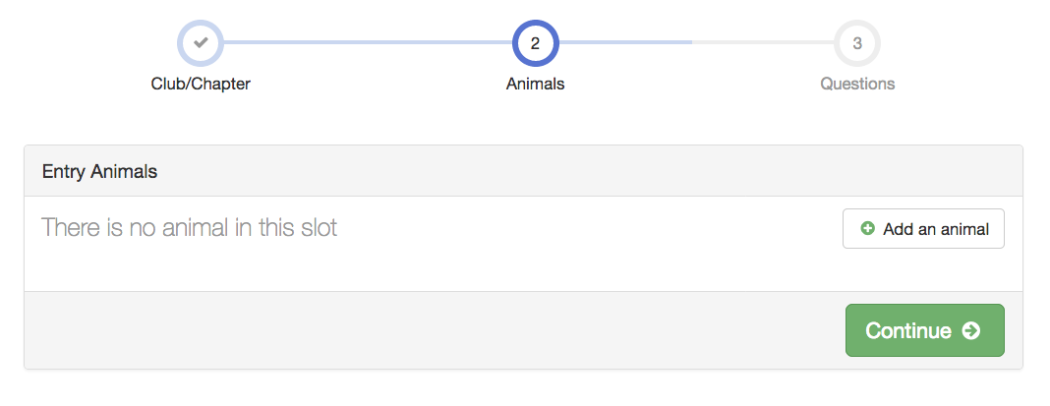  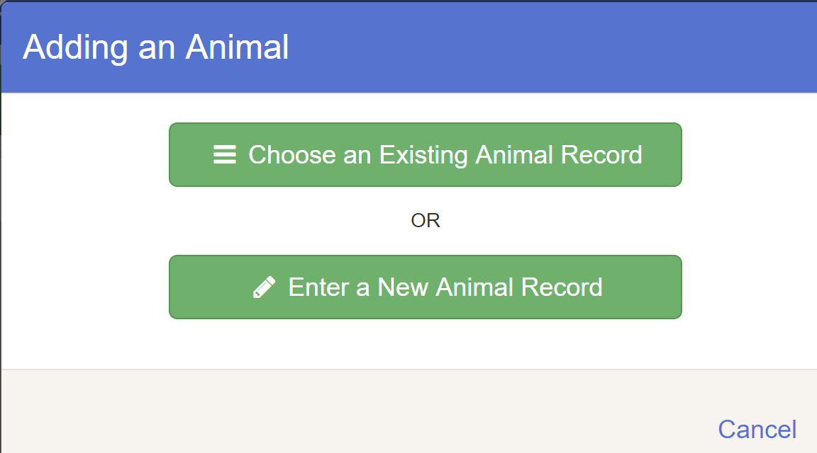  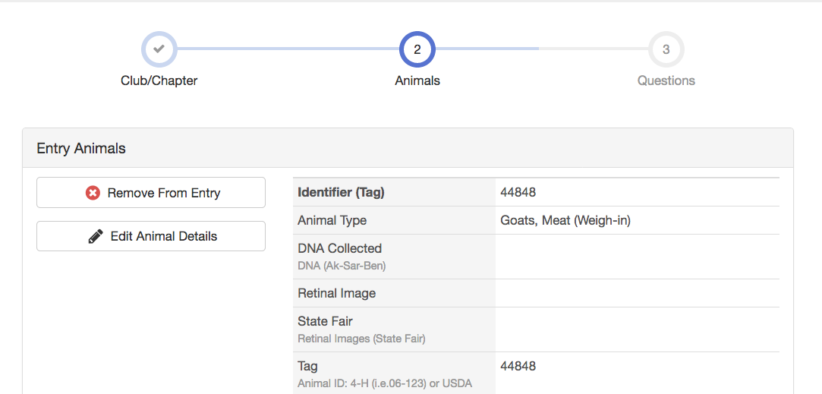
Any questions or file uploads related to entry in this class will be next. Click Continue after answering those questions or uploading documents.
- When each class entry is complete, you have three choices for what to do next:  - If all class entries have been completed for one exhibitor, you can Register another Exhibitor in this exhibitor group.  - If this exhibitor has more class entries to make, you can Add another Entry for this Exhibitor.  - If all entries for all exhibitors in the exhibitor group have been completed, Continue to Payment to finalize and submit your entries. | 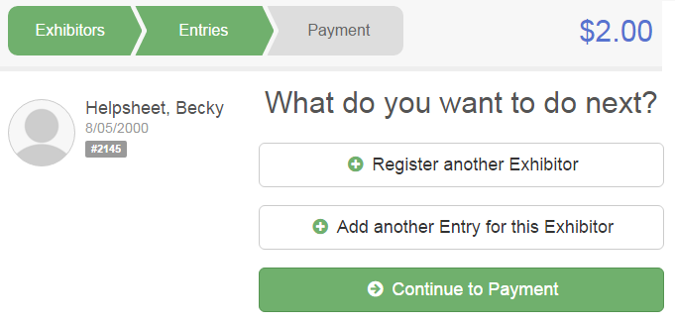
- Review your entries for completeness and accuracy. Notice the Summary and Detail buttons at the top of the list on the right. If there are errors, click on the green Entries section at the top of the page. Click Continue when all information is correct.  - Once all entries have been entered for exhibitors in your family, submit the invoice for approval.  You will receive an email message when the entries have been submitted for approval. You will receive a second email when the entries have been approved. | 